ARYAMAN MISHRA 19BCE1027 1)

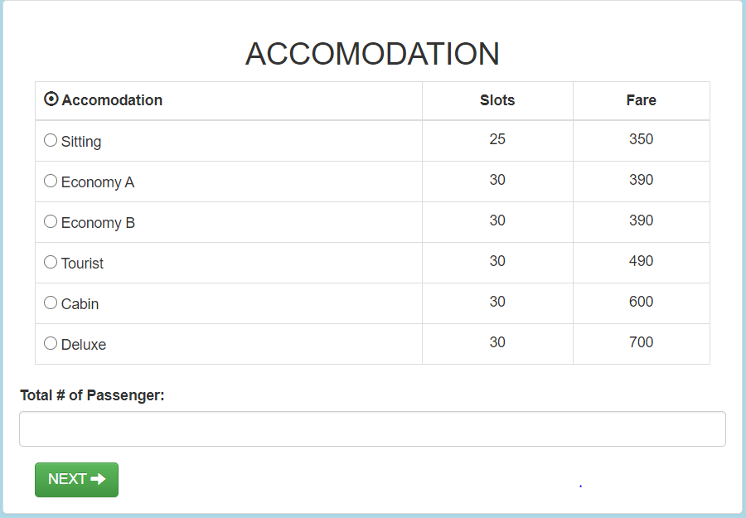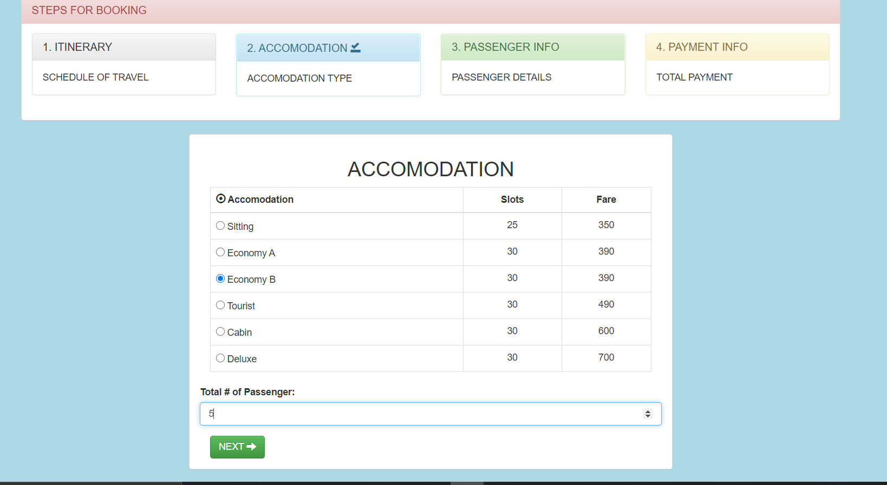

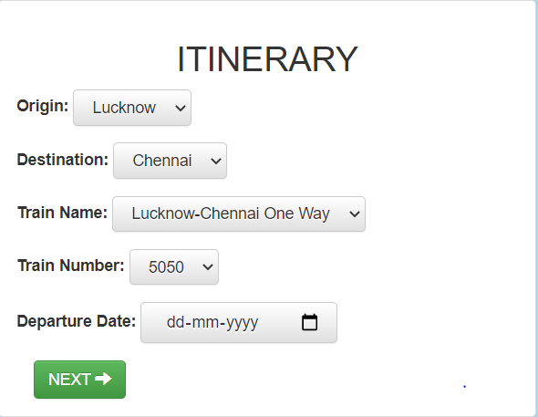

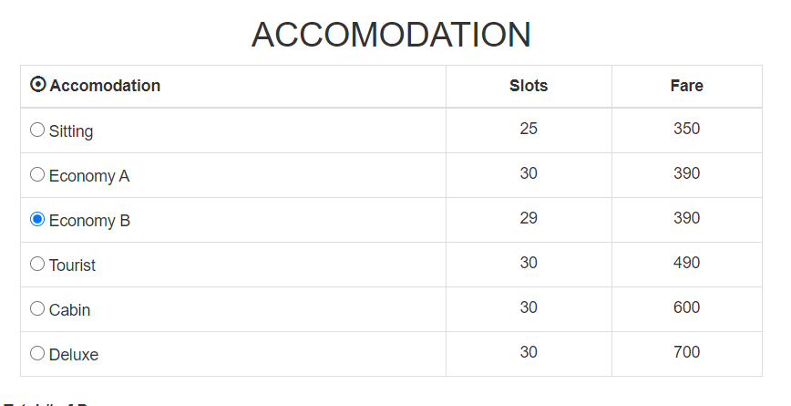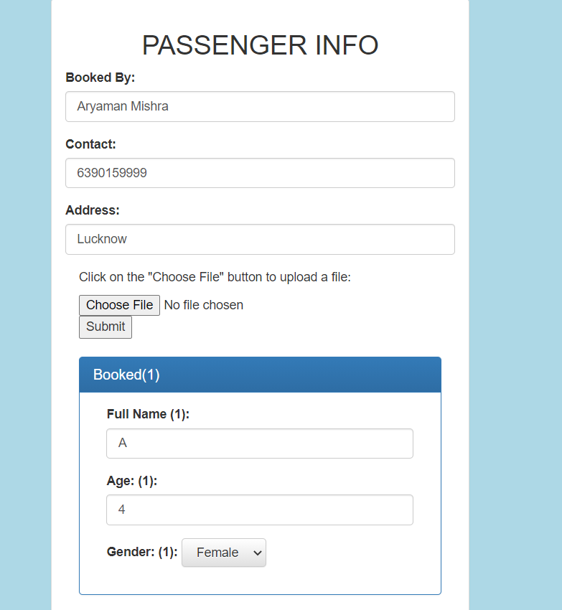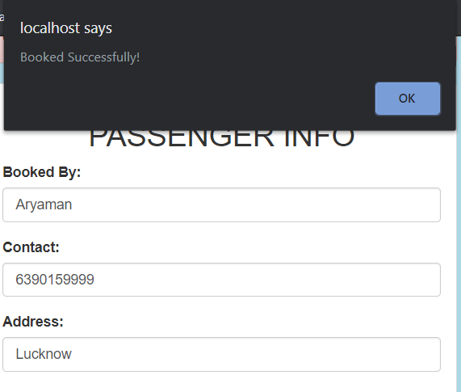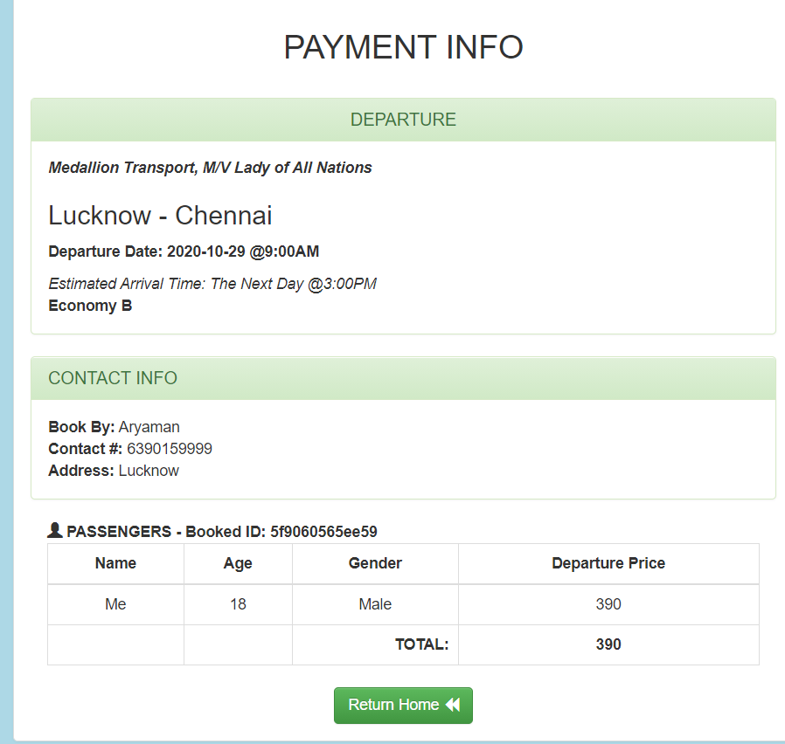

<?php

if(session_status() == PHP_SESSION_NONE)

{

session_start();//start session if session not start

}

if(isset($_SESSION['accomodation'])){

?>

<!DOCTYPE html>

<html lang="">

<head>

<meta charset="utf-8">

<meta http-equiv="X-UA-Compatible" content="IE=edge">

<meta name="viewport" content="width=device-width, initial-scale=1">

<title>Medallion</title>

<!-- Bootstrap CSS -->

<link rel="stylesheet" type="text/css" href="assets/css/bootstrap.min.css">

<link rel="stylesheet" type="text/css" href="assets/css/bootstrap-theme.min.css">

</head>

<body style="background-color: lightblue;">

<nav class="navbar navbar-inverse">

<div class="container-fluid">

<div class="navbar-header">

<a class="navbar-brand" href="#">Medallion Online Ticketing</a>

</div>

<ul class="nav navbar-nav">

<li class="active">

<a href="#">Rerservation

<span class="glyphicon glyphicon-share-alt" aria-hidden="true"></span>

</a>

</li>

</ul>

<ul class="nav navbar-nav navbar-right">

<li><a href="index.php"><span class="glyphicon glyphicon-backward"></span> Back To Home</a></li>

</ul>

</div>

</nav>

<div class="container-fluid">

<div class="col-md-1"></div>

<div class="col-md-10">

<div class="panel panel-danger">

<div class="panel-heading">

<h3 class="panel-title">STEPS FOR BOOKING</h3>

</div>

<div class="panel-body">

<div class="row">

<div class="col-md-3">

<div class="panel panel-default">

<div class="panel-heading">

<h3 class="panel-title">1. ITINERARY

</h3>

</div>

<div class="panel-body">

SCHEDULE OF TRAVEL

</div>

</div>

</div>

<div class="col-md-3">

<div class="panel panel-info">

<div class="panel-heading">

<h3 class="panel-title">2. ACCOMODATION

</h3>

</div>

<div class="panel-body">

ACCOMODATION TYPE

</div>

</div>

</div>

<div class="col-md-3">

<div class="panel panel-success">

<div class="panel-heading">

<h3 class="panel-title">3. PASSENGER INFO

<span class="glyphicon glyphicon-saved" aria-hidden="true"></span>

</h3>

</div>

<div class="panel-body">

PASSENGER DETAILS

</div>

</div>

</div>

<div class="col-md-3">

<div class="panel panel-warning">

<div class="panel-heading">

<h3 class="panel-title">4. PAYMENT INFO</h3>

</div>

<div class="panel-body">

TOTAL PAYMENT

</div>

</div>

</div>

</div>

</div>

</div>

</div>

<div class="col-md-1"></div>

</div>

<div class="container-fluid">

<div class="col-md-4"></div>

<div class="col-md-4">

<div class="alert alert-danger">

<button type="button" class="close" data-dismiss="alert" aria-hidden="true">&times;</button>

<strong>Message!</strong> Please review your passenger information.

You cannot change your reservation once you proceed.

</div>

<div class="panel panel-default">

<div class="panel-body">

<h2>

<center>PASSENGER INFO</center>

</h2>

<div class="container-fluid">

<form class="form-horizontal" role="form" id="form-pass">

<div class="form-group">

<label for="">Booked By:</label>

<input type="text" class="form-control" id="book-by" placeholder="Enter Name"

autofocus="" required="" autocomplete="off">

</div>

<div class="form-group">

<label for="">Contact:</label>

<input type="text" class="form-control" id="cont" placeholder="Enter Contact" required="" autocomplete="off">

</div>

<div class="form-group">

<label for="">Address:</label>

<input type="text" class="form-control" id="address" placeholder="Enter Address" required="" autocomplete="off">

</div>

<br />

<?php

$tb = $_SESSION['totalPass'];

$count = 1;

for($i = 0; $i < $tb; $i++){

?>

<div class="panel panel-primary">

<div class="panel-heading">

<h3 class="panel-title">Booked(<?= $count; ?>)</h3>

</div>

<div class="panel-body">

<div class="container-fluid">

<div class="form-group">

<label for="">Full Name (<?= $count; ?>):</label>

<input type="text" class="form-control" id="fN<?php echo $i; ?>"

placeholder="Enter Fullname" required autocomplete="off">

</div>

<div class="form-group">

<label for="">Age: (<?= $count; ?>):</label>

<input type="number" class="form-control" id="age<?php echo $i; ?>"

placeholder="Enter Age" required autocomplete="off">

</div>

<div class="form-group">

<label for="">Gender: (<?= $count; ?>):</label>

<select class="btn btn-default" id="gender<?php echo $i; ?>">

<option value="Male">Male</option>

<option value="Female">Female</option>

</select>

</div>

</div>

</div>

</div>

<?php

$count++;

}//end for

?>

<button type="submit" class="btn btn-success">NEXT

<span class="glyphicon glyphicon-arrow-right" aria-hidden="true"></span>

</button>

</form>

</div>

</div>

</div>

</div>

<div class="col-md-4"></div>

</div>

<?php require_once('admin/modal/message.php'); ?>

<script type="text/javascript" src="assets/js/jquery-3.1.1.min.js"></script>

<script type="text/javascript" src="assets/js/bootstrap.min.js"></script>

<script type="text/javascript">

$(document).on('submit', '#form-pass', function(event) {

event.preventDefault();

/* Act on the event */

var bookBy = $('#book-by').val();

var cont = $('#cont').val();

var address = $('#address').val();

var counter = <?= $i; ?>;

for(var i = 0; i < counter; i++){

var fN = $('#fN'+i).val();

var age = $('#age'+i).val();

var gender = $('#gender'+i).val();

$.ajax({

url: 'data/save_booked.php',

type: 'post',

dataType: 'json',

data: {

bookBy : bookBy,

cont : cont,

address : address,

fN : fN,

age : age,

gender : gender

},

success: function (data) {

// console.log(data);

if(data.valid == true){

window.location = data.url;

}

},

error: function(){

// alert('Error: L192+');

}

});

}//end for

alert('Booked Successfully!');

});

</script>

</body>

</html>

<?php

}else{

echo '<strong>';

echo 'Page Not Exist';

echo '</strong>';

}//end if else isset

?>

<?php

require_once('data/get_origin.php');

require_once('data/get_destination.php');

// echo '<pre>';

// print_r($origins);

// echo '</pre>';

?>

<!DOCTYPE html>

<html lang="">

<head>

<meta charset="utf-8">

<meta http-equiv="X-UA-Compatible" content="IE=edge">

<meta name="viewport" content="width=device-width, initial-scale=1">

<title>Online Ticket Rerservation</title>

<!-- Bootstrap CSS -->

<link rel="stylesheet" type="text/css" href="assets/css/bootstrap.min.css">

<link rel="stylesheet" type="text/css" href="assets/css/bootstrap-theme.min.css">

</head>

<body style="background-color: lightblue;">

<nav class="navbar navbar-inverse">

<div class="container-fluid">

<div class="navbar-header">

<a class="navbar-brand" href="#">Online Ticketing</a>

</div>

<ul class="nav navbar-nav">

<li class="active">

<a href="#">Rerservation

<span class="glyphicon glyphicon-share-alt" aria-hidden="true"></span>

</a>

</li>

</ul>

<ul class="nav navbar-nav navbar-right">

<li><a href="index.php"><span class="glyphicon glyphicon-backward"></span> Back To Home</a></li>

</ul>

</div>

</nav>

<div class="container-fluid">

<div class="col-md-1"></div>

<div class="col-md-10">

<div class="panel panel-danger">

<div class="panel-heading">

<h3 class="panel-title">STEPS FOR BOOKING</h3>

</div>

<div class="panel-body">

<div class="row">

<div class="col-md-3">

<div class="panel panel-default">

<div class="panel-heading">

<h3 class="panel-title">1. ITINERARY

<span class="glyphicon glyphicon-saved" aria-hidden="true"></span>

</h3>

</div>

<div class="panel-body">

SCHEDULE OF TRAVEL

</div>

</div>

</div>

<div class="col-md-3">

<div class="panel panel-info">

<div class="panel-heading">

<h3 class="panel-title">2. ACCOMODATION</h3>

</div>

<div class="panel-body">

ACCOMODATION TYPE

</div>

</div>

</div>

<div class="col-md-3">

<div class="panel panel-success">

<div class="panel-heading">

<h3 class="panel-title">3. PASSENGER INFO</h3>

</div>

<div class="panel-body">

PASSENGER DETAILS

</div>

</div>

</div>

<div class="col-md-3">

<div class="panel panel-warning">

<div class="panel-heading">

<h3 class="panel-title">4. PAYMENT INFO</h3>

</div>

<div class="panel-body">

TOTAL PAYMENT

</div>

</div>

</div>

</div>

</div>

</div>

</div>

<div class="col-md-1"></div>

</div>

<div class="container-fluid">

<div class="col-md-4"></div>

<div class="col-md-4">

<div class="panel panel-default">

<div class="panel-body">

<h2>

<center>ITINERARY</center>

</h2>

<div class="container-fluid">

<form class="form-horizontal" role="form" id="form-itinerary">

<div class="form-group">

<label for="">Origin:</label>

<select class="btn btn-default" id="orig-id">

<?php foreach($origins as $o): ?>

<option value="<?= $o['origin_id']; ?>"><?= $o['origin_desc']; ?></option>

<?php endforeach; ?>

</select>

</div>

<div class="form-group">

<label for="">Destination:</label>

<select class="btn btn-default" id="dest-id">

<?php foreach($destinations as $d): ?>

<option value="<?= $d['dest_id']; ?>"><?= $d['dest_destination']; ?></option>

<?php endforeach; ?>

</select>

</div>

<div class="form-group">

<label for="">Train Name:</label>

<select class="btn btn-default" id="orig-id">

<?php foreach($origins as $o): ?>

<option value="<?= $o['origin_id']; ?>"><?= $o['train name']; ?></option>

<?php endforeach; ?>

</select>

</div>

<div class="form-group">

<label for="">Train Number:</label>

<select class="btn btn-default" id="orig-id">

<?php foreach($origins as $o): ?>

<option value="<?= $o['origin_id']; ?>"><?= $o['train number']; ?></option>

<?php endforeach; ?>

</select>

</div>

<div class="form-group">

<label for="">Departure Date:</label>

<input type="date" class="btn btn-default" id="dept-date">

</div>

<button type="submit" class="btn btn-success">NEXT

<span class="glyphicon glyphicon-arrow-right" aria-hidden="true"></span>

</button>

</form>

</div>

</div>

</div>

</div>

<div class="col-md-4"></div>

</div>

<script type="text/javascript" src="assets/js/jquery-3.1.1.min.js"></script>

<script type="text/javascript" src="assets/js/bootstrap.min.js"></script>

<script type="text/javascript">

$(document).on('submit', '#form-itinerary', function(event) {

event.preventDefault();

/* Act on the event */

var validate = "";

var origin = $('select[id=orig-id]').val();

var dest = $('select[id=dest-id]').val();

var dept = $('input[id=dept-date]').val();

if(dept.length == 0){

alert('Please Select Departure Date!');

}else{

$.ajax({

url: 'data/session_itinerary.php',

type: 'post',

dataType: 'json',

data: {

oid : origin,

did : dest,

dd : dept

},

success: function (data) {

console.log(data);

if(data.valid == true){

window.location = data.url;

console.log('sss');

}

},

error: function(){

alert('Error: L161+');

}

});

}//end dept kung == 0

});

</script>

</body>

</html><?php

if(session_status() == PHP_SESSION_NONE)

{

session_start();//start session if session not start

}

if(isset($_SESSION['departure_date'])){

?>

<!DOCTYPE html>

<html lang="">

<head>

<meta charset="utf-8">

<meta http-equiv="X-UA-Compatible" content="IE=edge">

<meta name="viewport" content="width=device-width, initial-scale=1">

<title>Medallion</title>

<!-- Bootstrap CSS -->

<link rel="stylesheet" type="text/css" href="assets/css/bootstrap.min.css">

<link rel="stylesheet" type="text/css" href="assets/css/bootstrap-theme.min.css">

</head>

<body style="background-color: lightblue;">

<nav class="navbar navbar-inverse">

<div class="container-fluid">

<div class="navbar-header">

<a class="navbar-brand" href="#">Medallion Online Ticketing</a>

</div>

<ul class="nav navbar-nav">

<li class="active">

<a href="#">Rerservation

<span class="glyphicon glyphicon-share-alt" aria-hidden="true"></span>

</a>

</li>

</ul>

<ul class="nav navbar-nav navbar-right">

<li><a href="index.php"><span class="glyphicon glyphicon-backward"></span> Back To Home</a></li>

</ul>

</div>

</nav>

<div class="container-fluid">

<div class="col-md-1"></div>

<div class="col-md-10">

<div class="panel panel-danger">

<div class="panel-heading">

<h3 class="panel-title">STEPS FOR BOOKING</h3>

</div>

<div class="panel-body">

<div class="row">

<div class="col-md-3">

<div class="panel panel-default">

<div class="panel-heading">

<h3 class="panel-title">1. ITINERARY

</h3>

</div>

<div class="panel-body">

SCHEDULE OF TRAVEL

</div>

</div>

</div>

<div class="col-md-3">

<div class="panel panel-info">

<div class="panel-heading">

<h3 class="panel-title">2. ACCOMODATION

<span class="glyphicon glyphicon-saved" aria-hidden="true"></span>

</h3>

</div>

<div class="panel-body">

ACCOMODATION TYPE

</div>

</div>

</div>

<div class="col-md-3">

<div class="panel panel-success">

<div class="panel-heading">

<h3 class="panel-title">3. PASSENGER INFO</h3>

</div>

<div class="panel-body">

PASSENGER DETAILS

</div>

</div>

</div>

<div class="col-md-3">

<div class="panel panel-warning">

<div class="panel-heading">

<h3 class="panel-title">4. PAYMENT INFO</h3>

</div>

<div class="panel-body">

TOTAL PAYMENT

</div>

</div>

</div>

</div>

</div>

</div>

</div>

<div class="col-md-1"></div>

</div>

<div class="container-fluid">

<div class="col-md-3"></div>

<div class="col-md-6">

<div class="panel panel-default">

<div class="panel-body">

<h2>

<center>ACCOMODATION</center>

</h2>

<div class="container-fluid">

<form class="form-horizontal" role="form" id="form-acc">

<table id="myTable-party" class="table table-bordered table-hover" cellspacing="0" width="100%">

<thead>

<tr>

<th> <span class="glyphicon glyphicon-record" aria-hidden="true"></span>

Accomodation

</th>

<th>

<center>

Slots

</center>

</th>

<th>

<center>

Fare

</center>

</th>

</tr>

</thead>

<tbody>

<?php require_once('data/get_all_accomodations.php'); ?>

<tr>

<td>

<input value="<?= $getSit['acc_id']; ?>" type="radio" name="acc">

<?= $getSit['acc_type']; ?>

</td>

<td align="center">

<?= $getSit['acc_slot'] - $totalSit['sit']; ?>

</td>

<td align="center"><?= $getSit['acc_price']; ?></td>

</tr>

<tr>

<td>

<input value="<?= $getEcoA['acc_id']; ?>" type="radio" name="acc">

<?= $getEcoA['acc_type']; ?>

</td>

<td align="center">

<?= $getEcoA['acc_slot'] - $totalEcoA['ecoA']; ?>

</td>

<td align="center"><?= $getEcoA['acc_price']; ?></td>

</tr>

<tr>

<td>

<input value="<?= $getEcoB['acc_id']; ?>" type="radio" name="acc">

<?= $getEcoB['acc_type']; ?>

</td>

<td align="center">

<?= $getEcoB['acc_slot'] - $totalEcoB['ecoB']; ?>

</td>

<td align="center"><?= $getEcoB['acc_price']; ?></td>

</tr>

<tr>

<td>

<input value="<?= $getTour['acc_id']; ?>" type="radio" name="acc">

<?= $getTour['acc_type']; ?>

</td>

<td align="center">

<?= $getTour['acc_slot'] - $totalTour['ecoT']; ?>

</td>

<td align="center"><?= $getTour['acc_price']; ?></td>

</tr>

<tr>

<td>

<input value="<?= $getCab['acc_id']; ?>" type="radio" name="acc">

<?= $getCab['acc_type']; ?>

</td>

<td align="center">

<?= $getCab['acc_slot'] - $totalCab['ecoC']; ?>

</td>

<td align="center"><?= $getCab['acc_price']; ?></td>

</tr>

<tr>

<td>

<input value="<?= $getDel['acc_id']; ?>" type="radio" name="acc">

<?= $getDel['acc_type']; ?>

</td>

<td align="center">

<?= $getDel['acc_slot'] - $totalDel['ecoD']; ?>

</td>

<td align="center"><?= $getDel['acc_price']; ?></td>

</tr>

</tbody>

</table>

<div class="form-group">

<label for="">Total # of Passenger:</label>

<input type="number" min="1" class="form-control" name="totalPass" plactreholder="Total # of Passenger" autocomplete="off">

</div>

<button type="submit" class="btn btn-success">NEXT

<span class="glyphicon glyphicon-arrow-right" aria-hidden="true"></span>

</button>

</form>

</div>

</div>

</div>

</div>

<div class="col-md-3"></div>

</div>

<script type="text/javascript" src="assets/js/jquery-3.1.1.min.js"></script>

<script type="text/javascript" src="assets/js/bootstrap.min.js"></script>

<script type="text/javascript">

$(document).on('submit', '#form-acc', function(event) {

event.preventDefault();

/* Act on the event */

var acc = $('input[name="acc"]:checked').val();

var totalPass = $('input[name="totalPass"]').val();

if(acc == null){

alert('Please Select Accomodation!');

}else{

// console.log(acc);

if(totalPass.length == 0){

alert('Please Enter Number of Passenger!');

}else{

$.ajax({

url: 'data/session_accomodation.php',

type: 'post',

dataType: 'json',

data: {

acc : acc,

tp : totalPass

},

success: function (data) {

console.log(data.slot);

// window.location = "passenger.php";

if(data.slot >= 0){

window.location = "passenger.php";

}else{

alert('Not Enough Slot!');

}

},

error: function(){

alert('Error: L175+');

}

});

}//end totalPass

}//end acc == null

});

</script>

</body>

</html>

<?php

}else{

echo '<strong>';

echo 'Page Not Exist';

echo '</strong>';

}//end if else isset

?>

<!DOCTYPE html>

<head>

<meta charset="utf-8">

<meta name="viewport" content="width=devidev-width, initial-scale=1.0, maximum-scale=1.0, user-scalable=no">

<meta http-equiv="X-UA-Compatible" content="IE=edge">

<title>Online Ticket Reservation</title>

<!-- [ FONT-AWESOME ICON ]

=========================================================================================================================-->

<link rel="stylesheet" type="text/css" href="library/font-awesome-4.3.0/css/font-awesome.min.css">

<!-- [ PLUGIN STYLESHEET ]

=========================================================================================================================-->

<link rel="shortcut icon" type="image/x-icon" href="images/icon.png">

<link rel="stylesheet" type="text/css" href="css/animate.css">

<link rel="stylesheet" type="text/css" href="css/owl.carousel.css">

<link rel="stylesheet" type="text/css" href="css/owl.theme.css">

<link rel="stylesheet" type="text/css" href="css/magnific-popup.css">

<!-- [ Boot STYLESHEET ]

=========================================================================================================================-->

<link rel="stylesheet" type="text/css" href="library/bootstrap/css/bootstrap-theme.min.css">

<link rel="stylesheet" type="text/css" href="library/bootstrap/css/bootstrap.css">

<!-- [ DEFAULT STYLESHEET ]

=========================================================================================================================-->

<link rel="stylesheet" type="text/css" href="css/style.css">

<link rel="stylesheet" type="text/css" href="css/responsive.css">

<link rel="stylesheet" type="text/css" href="css/color/rose.css">

</head>

<body >

<!-- [ LOADERs ]

================================================================================================================================-->

<div class="preloader">

<div class="loader theme_background_color">

<span></span>

</div>

</div>

<!-- [ /PRELOADER ]

=============================================================================================================================-->

<!-- [WRAPPER ]

=============================================================================================================================-->

<div class="wrapper">

<!-- [NAV]

============================================================================================================================-->

<!-- Navigation

==========================================-->

<nav class=" nim-menu navbar navbar-default navbar-fixed-top">

<div class="container">

<!-- Brand and toggle get grouped for better mobile display -->

<div class="navbar-header">

<button type="button" class="navbar-toggle collapsed" data-toggle="collapse" data-target="#bs-example-navbar-collapse-1">

<span class="sr-only">Toggle navigation</span>

<span class="icon-bar"></span>

<span class="icon-bar"></span>

<span class="icon-bar"></span>

</button>

<a class="navbar-brand" href="index.html">Online<span class="themecolor"> T</span>ickets</a>

</div>

<!-- Collect the nav links, forms, and other content for toggling -->

<div class="collapse navbar-collapse" id="bs-example-navbar-collapse-1">

<ul class="nav navbar-nav navbar-right">

<li><a href="#home" class="page-scroll"><h3>Home</h3></a></li>

<li><a href="#two" class="page-scroll"><h3>About</h3></a></li>

<li><a href="#one" class="page-scroll"><h3>Inspiration</h3></a></li>

<li><a href="#three" class="page-scroll"><h3>Services</h3></a></li>

<li><a href="#four" class="page-scroll"><h3>Contact</h3></a></li>

<li><a href="admin/" class="page-scroll"><h3>Login</h3></a></li>

</ul>

</div>

<!-- /.navbar-collapse -->

</div><!-- /.container-fluid -->

</nav>

<!-- [/NAV]

============================================================================================================================-->

<!-- [/MAIN-HEADING]

============================================================================================================================-->

<section class="main-heading" id="home">

<div class="overlay">

<div class="container">

<div class="row">

<div class="main-heading-content col-md-12 col-sm-12 text-center">

<h1 class="main-heading-title"><span class="main-element themecolor" data-elements=" Online Ticket, Online Ticket, Online Ticket"></span></h1>

<h1 class="main-heading-title"><span class="main-element themecolor" data-elements=" Reservation System, Reservation System, Reservation System"></span></h1>

<p class="main-heading-text">WELCOME TO,<br/>ONLINE TICKET RESERVATION SYSTEM</p>

<div class="btn-bar">

<a href="reserved.php" class="btn btn-custom theme_background_color">Reserve Now</a>

</div>

</div>

</div>

</div>

</div>

</section>

<section class="main-heading" id="home">

<div class="overlay">

<div class="container">

<div class="row">

<div class="main-heading-content col-md-12 col-sm-12 text-center">

<h1 class="main-heading-title">We are Creative</h1>

<p class="main-heading-text">Et harum quidem rerum facilis est et expedita distinctio. Nam libero tempore,

<br/>cum soluta nobis est eligendi optio cumque nihil impedit quo facilis</p>

<div class="btn-bar">

<a href="#" class="btn btn-custom theme_background_color">Ge Started</a>

<a href="#" class="btn btn-custom-outline">Contact Us</a>

</div>

</div>

</div>

</div>

</div>

</section>

<!-- [/MAIN-HEADING]

============================================================================================================================-->

<!-- [ABOUT US]

============================================================================================================================-->

<section class="aboutus white-background black" id="one">

<div class="container">

<div class="row">

<div class="col-md-12 text-center black">

<h3 class="title">ABOUT <span class="themecolor">US</span></h3>

<p class="a-slog">Lorem ipsum dolor sit amet ne onsectetuer adipiscing elit. Aenean commodo ligula eget dolor in tashin ty</p>

</div>

</div>

<div class="gap">

</div>

<div class="row about-box">

<div class="col-sm-4 text-center">

<div class="margin-bottom">

<i class="fa fa-newspaper-o"></i>

<h4>POWER OF FLEXIBILITY</h4>

<p class="black">Nulla vitae libero pharetra augue. Etiam porta malesuada magna mollis euismod consectetur sem urdom tempus porttitor.</p>

</div> <!-- / margin -->

</div> <!-- /col -->

<div class="col-sm-4 about-line text-center">

<div class="margin-bottom">

<i class="fa fa-diamond"></i>

<h4>FULLY RESPONSIVE</h4>

<p class="black">Nulla vitae libero pharetra augue. Etiam porta malesuada magna mollis euismod consectetur sem urdom tempus porttitor.</p>

</div> <!-- / margin -->

</div><!-- /col -->

<div class="col-sm-4 text-center">

<div class="margin-bottom">

<i class="fa fa-area-chart"></i>

<h4>GREAT WEB IDEAS</h4>

<p class="black">Nulla vitae libero pharetra augue. Etiam porta malesuada magna mollis euismod consectetur sem urdom tempus porttitor.</p>

</div> <!-- / margin -->

</div><!-- /col -->

</div> <!-- /row -->

</div>

</section>

<!-- [/ABOUTUS]

============================================================================================================================-->

<!-- [INSPIRATION]

============================================================================================================================-->

<section class="inspiration" id="four">

<div class="overlay">

<div class="container">

<div class="row">

<article class="col-md-12 text-center">

<div class="intermediate-container">

<div class="subheading">

<h4>Are You Ready To <span class="themecolor">Enjoy?</span></h4>

</div>

<div class="heading">

<h2>inspire your customer here!</h2>

</div>

<div class="">

<a class="btn btn-custom-outline" href="#"><span>get started</span></a>

</div>

</div>

</article>

</div>

</div>

</div>

</section>

<!-- [/INSPIRATION]

============================================================================================================================-->

<!-- [/SERVICES]

============================================================================================================================-->

<section class="services white-background black" id="seven">

<div class="container">

<div class="row text-center">

<div class="col-md-12">

<h3 class="title">We Are <span class="themecolor">Good In</span></h3>

<p class="a-slog">Lorem ipsum dolor sit amet ne onsectetuer adipiscing elit. Aenean commodo ligula eget dolor in tashin ty</p>

</div> <!-- /col -->

</div> <!-- /row -->

<div class="gap"></div>

<div class="row">

<div class="col-sm-4">

<div class="nim-service margin-bottom">

<i class="fa fa-diamond"></i>

<div class="nim-service-detail">

<h4>Strategy Solutions</h4>

<p>Lorem ipsum dolor sit amet ne onsectetuer adipiscing elit. Aenean commodo ligula eget dolor in tashin ty dolor site amet ne onseceruter adipiscing</p>

</div> <!-- /nim-service-detail -->

</div> <!-- /nim-service margin-bottom -->

</div> <!-- /col -->

<div class="col-sm-4">

<div class="nim-service margin-bottom">

<i class="fa fa-tablet"></i>

<div class="nim-service-detail">

<h4>Digital Design</h4>

<p>Lorem ipsum dolor sit amet ne onsectetuer adipiscing elit. Aenean commodo ligula eget dolor in tashin ty dolor site amet ne onseceruter adipiscing</p>

</div> <!-- /nim-service-detail -->

</div> <!-- /nim-service margin-bottom -->

</div> <!-- /col -->

<div class="col-sm-4">

<div class="nim-service margin-bottom">

<i class="fa fa-magic"></i>

<div class="nim-service-detail">

<h4>SEO</h4>

<p>Lorem ipsum dolor sit amet ne onsectetuer adipiscing elit. Aenean commodo ligula eget dolor in tashin ty dolor site amet ne onseceruter adipiscing</p>

</div> <!-- /nim-service-detail -->

</div> <!-- /nim-service margin-bottom -->

</div> <!-- /col -->

</div> <!-- end row -->

<div class="row">

<div class="col-sm-4">

<div class="nim-service margin-bottom">

<i class="fa fa-rocket"></i>

<div class="nim-service-detail">

<h4>Graphic Design</h4>

<p>Lorem ipsum dolor sit amet ne onsectetuer adipiscing elit. Aenean commodo ligula eget dolor in tashin ty dolor site amet ne onseceruter adipiscing</p>

</div> <!-- /nim-service-detail -->

</div> <!-- /nim-service margin-bottom -->

</div> <!-- /col -->

<div class="col-sm-4">

<div class="nim-service margin-bottom">

<i class="fa fa-map-marker"></i>

<div class="nim-service-detail">

<h4>Analystics</h4>

<p>Lorem ipsum dolor sit amet ne onsectetuer adipiscing elit. Aenean commodo ligula eget dolor in tashin ty dolor site amet ne onseceruter adipiscing</p>

</div> <!-- /nim-service-detail -->

</div> <!-- /nim-service margin-bottom -->

</div> <!-- /col -->

<div class="col-sm-4">

<div class="nim-service margin-bottom">

<i class="fa fa-paypal"></i>

<div class="nim-service-detail">

<h4>Dedicated Support</h4>

<p>Lorem ipsum dolor sit amet ne onsectetuer adipiscing elit. Aenean commodo ligula eget dolor in tashin ty dolor site amet ne onseceruter adipiscing</p>

</div> <!-- /nim-service-detail -->

</div> <!-- /nim-service margin-bottom -->

</div> <!-- /col -->

</div> <!-- end row -->

<div class="row">

<div class="col-sm-4">

<div class="nim-service margin-bottom">

<i class="fa fa-bar-chart-o"></i>

<div class="nim-service-detail">

<h4>Truly Multipurpose</h4>

<p>Lorem ipsum dolor sit amet ne onsectetuer adipiscing elit. Aenean commodo ligula eget dolor in tashin ty dolor site amet ne onseceruter adipiscing</p>

</div> <!-- /nim-service-detail -->

</div> <!-- /nim-service margin-bottom -->

</div> <!-- /col -->

<div class="col-sm-4">

<div class="nim-service margin-bottom">

<i class="fa fa-delicious"></i>

<div class="nim-service-detail">

<h4>Unlimited Colors</h4>

<p>We put a lot of effort in design, as it’s the most important ingredient of successful website.Sed ut perspiciatis unde omnis iste natus error sit.</p>

</div> <!-- /nim-service-detail -->

</div> <!-- /nim-service margin-bottom -->

</div> <!-- /col -->

<div class="col-sm-4">

<div class="nim-service margin-bottom">

<i class="fa fa-pencil-square"></i>

<div class="nim-service-detail">

<h4>Easy to customize</h4>

<p>Lorem ipsum dolor sit amet ne onsectetuer adipiscing elit. Aenean commodo ligula eget dolor in tashin ty dolor site amet ne onseceruter adipiscing</p>

</div> <!-- /nim-service-detail -->

</div> <!-- /nim-service margin-bottom -->

</div> <!-- /col -->

</div> <!-- end row -->

</div> <!-- container -->

</section>

<!-- [/SERVICES]

============================================================================================================================-->

<!-- [CONTACT]

============================================================================================================================-->

<!--sub-form-->

<section class="sub-form text-center" id="eight">

<div class="container">

<div class="col-md-12">

<h3 class="title">Subscribe to our <span class="themecolor"> News letter</span></h3>

<p class="lead">Lorem ipsum dolor sit amet ne onsectetuer adipiscing elit. Aenean commodo ligula eget dolor in tashin ty</p>

</div>

<div class="row">

<div class="col-md-3 col-sm-3"></div>

<div class="col-md-6 center-block col-sm-6 ">

<form id="mc-form">

<div class="input-group">

<input type="email" class="form-control" placeholder="Email Address" required id="mc-email">

<span class="input-group-btn">

<button type="submit" class="btn btn-default">SUBSCRIBE <i class="fa fa-envelope"></i> </button>

</span> </div>

<label for="mc-email" id="mc-notification"></label>

</form>

</div>

</div>

</div>

</section>

<!--sub-form end-->

<!-- [/CONTACT]

============================================================================================================================-->

<!-- [FOOTER]

============================================================================================================================-->

<footer class="site-footer section-spacing text-center " id="eight">

<div class="container">

<div class="row">

<div class="col-md-4">

<p class="footer-links"><a href="#">Terms of Use</a> <a href="#">Privacy Policy</a></p>

</div>

<div class="col-md-4"> <small>&copy; 2018, Brought To You By <a href="https://code-projects.org/">code-projects.org</a> </small></div>

<div class="col-md-4">

<!--social-->

<ul class="social">

<li><a href="https://twitter.com/" target="_blank"><i class="fa fa-twitter "></i></a></li>

<li><a href="https://www.facebook.com/" target="_blank"><i class="fa fa-facebook"></i></a></li>

<li><a href="https://www.youtube.com/" target="_blank"><i class="fa fa-youtube-play"></i></a></li>

</ul>

<!--social end-->

</div>

</div>

</div>

</footer>

<!-- [/FOOTER]

============================================================================================================================-->

</div>

<!-- [ /WRAPPER ]

=============================================================================================================================-->

<!-- [ DEFAULT SCRIPT ] -->

<script src="library/modernizr.custom.97074.js"></script>

<script src="library/jquery-1.11.3.min.js"></script>

<script src="library/bootstrap/js/bootstrap.js"></script>

<script type="text/javascript" src="js/jquery.easing.1.3.js"></script>

<!-- [ PLUGIN SCRIPT ] -->

<script src="library/vegas/vegas.min.js"></script>

<script src="js/plugins.js"></script>

<!-- [ TYPING SCRIPT ] -->

<script src="js/typed.js"></script>

<!-- [ COUNT SCRIPT ] -->

<script src="js/fappear.js"></script>

<script src="js/jquery.countTo.js"></script>

<!-- [ SLIDER SCRIPT ] -->

<script src="js/owl.carousel.js"></script>

<script src="js/jquery.magnific-popup.min.js" type="text/javascript"></script>

<script type="text/javascript" src="js/SmoothScroll.js"></script>

<!-- [ COMMON SCRIPT ] -->

<script src="js/common.js"></script>

</body>

</html><?php

if(session_status() == PHP_SESSION_NONE)

{

session_start();//start session if session not start

}

if(isset($_SESSION['tracker'])){

?>

<!DOCTYPE html>

<html lang="">

<head>

<meta charset="utf-8">

<meta http-equiv="X-UA-Compatible" content="IE=edge">

<meta name="viewport" content="width=device-width, initial-scale=1">

<title>Medallion</title>

<!-- Bootstrap CSS -->

<link rel="stylesheet" type="text/css" href="assets/css/bootstrap.min.css">

<link rel="stylesheet" type="text/css" href="assets/css/bootstrap-theme.min.css">

</head>

<body style="background-color: lightblue;">

<nav class="navbar navbar-inverse">

<div class="container-fluid">

<div class="navbar-header">

<a class="navbar-brand" href="#">Medallion Online Ticketing</a>

</div>

<ul class="nav navbar-nav">

<li class="active">

<a href="#">Rerservation

<span class="glyphicon glyphicon-share-alt" aria-hidden="true"></span>

</a>

</li>

</ul>

<ul class="nav navbar-nav navbar-right">

<li><a href="index.php"><span class="glyphicon glyphicon-backward"></span> Back To Home</a></li>

</ul>

</div>

</nav>

<div class="container-fluid">

<div class="col-md-1"></div>

<div class="col-md-10">

<div class="panel panel-danger">

<div class="panel-heading">

<h3 class="panel-title">STEPS FOR BOOKING</h3>

</div>

<div class="panel-body">

<div class="row">

<div class="col-md-3">

<div class="panel panel-default">

<div class="panel-heading">

<h3 class="panel-title">1. ITINERARY

</h3>

</div>

<div class="panel-body">

SCHEDULE OF TRAVEL

</div>

</div>

</div>

<div class="col-md-3">

<div class="panel panel-info">

<div class="panel-heading">

<h3 class="panel-title">2. ACCOMODATION

</h3>

</div>

<div class="panel-body">

ACCOMODATION TYPE

</div>

</div>

</div>

<div class="col-md-3">

<div class="panel panel-success">

<div class="panel-heading">

<h3 class="panel-title">3. PASSENGER INFO

</h3>

</div>

<div class="panel-body">

PASSENGER DETAILS

</div>

</div>

</div>

<div class="col-md-3">

<div class="panel panel-warning">

<div class="panel-heading">

<h3 class="panel-title">4. PAYMENT INFO

<span class="glyphicon glyphicon-saved" aria-hidden="true"></span>

</h3>

</div>

<div class="panel-body">

TOTAL PAYMENT

</div>

</div>

</div>

</div>

</div>

</div>

</div>

<div class="col-md-1"></div>

</div>

<div class="container-fluid">

<div class="col-md-3"></div>

<div class="col-md-6">

<div class="panel panel-default">

<div class="panel-body">

<h2>

<center>PAYMENT INFO</center>

</h2>

<br />

<div class="panel panel-success">

<div class="panel-heading">

<h3 class="panel-title"><center>DEPARTURE</center></h3>

</div>

<div class="panel-body">

<strong>

<i>Medallion Transport, M/V Lady of All Nations</i>

<h3>

<?php require_once('data/depart_from_to.php');

echo $origin['origin_desc'];

?>

-

<?= $dest['dest_destination']; ?>

</h3>

<p>Departure Date: <?= $_SESSION['departure_date']; ?> @9:00AM</p>

</strong>

<i>Estimated Arrival Time: The Next Day @3:00PM</i><br />

<strong>

<?php require_once('data/get_accomodation.php');

echo $accomodation['acc_type'];

?>

</strong>

</div>

</div>

<div class="panel panel-success">

<div class="panel-heading">

<h3 class="panel-title">CONTACT INFO</h3>

</div>

<div class="panel-body">

<?php require_once('data/getBooked.php'); ?>

<strong>Book By:</strong> <?= ucwords($bookByInfo['book_by']); ?><br />

<strong>Contact #:</strong> <?= $bookByInfo['book_contact']; ?><br />

<strong>Address:</strong> <?= $bookByInfo['book_address']; ?><br />

</div>

</div>

<div class="container-fluid">

<strong>

<span class="glyphicon glyphicon-user" aria-hidden="true"></span>

PASSENGERS</strong>

<table id="myTable-party" class="table table-bordered table-hover" cellspacing="0" width="100%">

<thead>

<tr>

<th>

<center>

Name

</center>

</th>

<th>

<center>

Age

</center>

</th>

<th>

<center>

Gender

</center>

</th>

<th>

<center>

Departure Price

</center>

</th>

</tr>

</thead>

<tbody>

<?php

require_once('data/getBooked.php');

$totalPayment = 0;

$tracker = '';

foreach($bookPass as $bp):

$name = $bp['book_name'];

$name = ucwords($name);

$price = $bp['acc_price'];

$totalPayment += $price;

$tracker = $bp['book_tracker'];

?>

<tr align="center">

<td><?= $name; ?></td>

<td><?= $bp['book_age']; ?></td>

<td><?= $bp['book_gender']; ?></td>

<td><?= $price; ?></td>

</tr>

<?php endforeach; ?>

<tr>

<td></td>

<td></td>

<td align="right"><strong>TOTAL:</strong></td>

<td align="center"><strong><?= $totalPayment; ?></strong></td>

</tr>

</tbody>

<strong>- Booked ID: <?= $tracker; ?></strong>

</table>

<center>

<a href="index.php" class="btn btn-success">Return Home

<span class="glyphicon glyphicon-backward" aria-hidden="true"></span>

</a>

</center>

</div>

</div>

</div>

</div>

<div class="col-md-3"></div>

</div>

<script type="text/javascript" src="assets/js/jquery-3.1.1.min.js"></script>

<script type="text/javascript" src="assets/js/bootstrap.min.js"></script>

</body>

</html>

<?php

}else{

echo '<strong>';

echo 'Page Not Exist';

echo '</strong>';

}//end if else isset

?>

2) 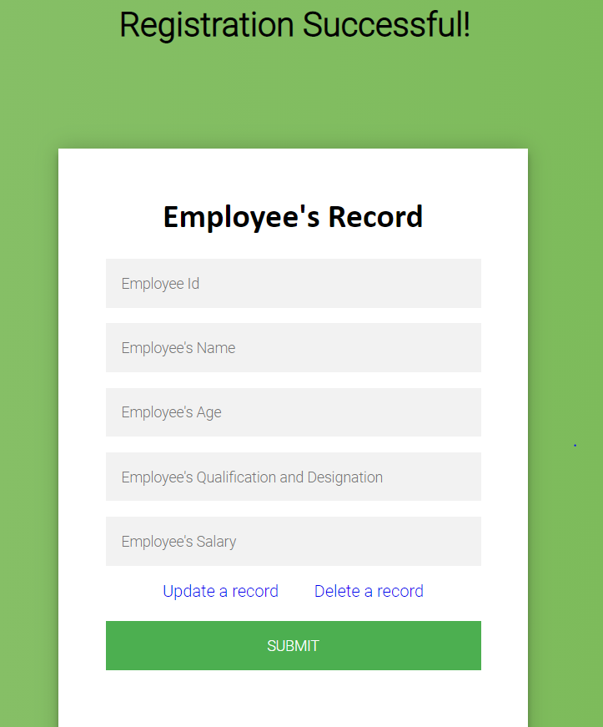

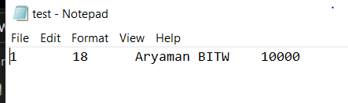

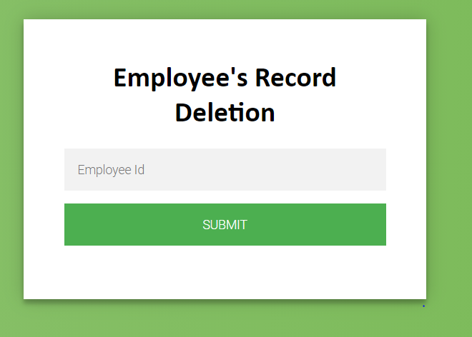

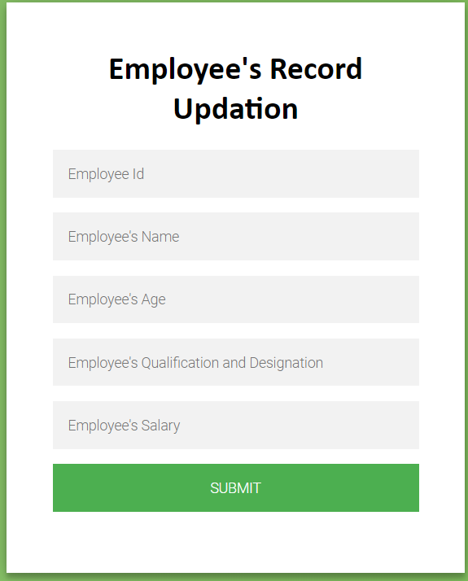

Index.php file:

<?php

if(isset($_POST['submit'])){

$conn = new mysqli('localhost','root','','iwp_db');

if($conn->connect_error){

echo "$conn->connect_error";

die("Connection Failed : ". $conn->connect_error);

}

else{

$ei=$_POST['ei'];$en=$_POST['en'];$ea=$_POST['ea'];$ed=$_POST['ed'];$es=$_POST['es'];

$qu="insert into employee values('$ei','$en','$ea','$ed','$es');";

$st=mysqli_query($conn,$qu);

if($st)

echo "<h1 align=center>Registration Successful!</h1>";

else

echo "<h1 align=center>Registration Unsuccessful!</h1>";

$file=fopen("test.txt", 'w');

fwrite($file, "");

fclose($file);

$f1=fopen("test.txt",'a');

$qu=mysqli_query($conn,"Select * from employee");

while($row=mysqli_fetch_assoc($qu)){

fwrite($f1,$row['emp_id']."\t".$row['emp_age']."\t".$row['emp_name']."\t".$row['emp_deg']."\t".$row['emp_sal']."\t"."\n");

}

fclose($f1);

}

}

?>

<!DOCTYPE html>

<html>

<body style="background-color: #9df">

<div id="demo">

<div class="Reservation-page">

<div class="form">

<form class="Reservation-form" method="post">

<h1 align="center" style="font-family: Calibri; margin-top: 0px;">Employee's Record</h1>

<input type="text" name="ei" placeholder="Employee Id" required="" />

<input type="text" name="en" placeholder="Employee's Name" required="" />

<input type="text" name="ea" placeholder="Employee's Age" required="" />

<input type="text" name="ed" placeholder="Employee's Qualification and Designation" required="" />

<input type="text" name="es" placeholder="Employee's Salary" required="" />

<a href="up.php">Update a record</a>

<a href="del.php" style="margin-left: 30px;">Delete a record</a><br><br>

<input type="submit" name="submit">

</form>

</div>

</div>

<style type="text/css">

@import url(https://fonts.googleapis.com/css?family=Roboto:300);

.login-page {

width: 360px;

padding: 8% 0 0;

margin: auto;

}

.form {

margin-top: 100px;

margin-left: 525px;

position: relative;

z-index: 1;

background: #FFFFFF;

max-width: 360px;

padding: 45px;

text-align: center;

box-shadow: 0 0 20px 0 rgba(0, 0, 0, 0.2), 0 5px 5px 0 rgba(0, 0, 0, 0.24);

}

.form input {

font-family: "Roboto", sans-serif;

outline: 0;

background: #f2f2f2;

width: 100%;

border: 0;

margin: 0 0 15px;

padding: 15px;

box-sizing: border-box;

font-size: 14px;

}

.form input[type=submit] {

font-family: "Roboto", sans-serif;

text-transform: uppercase;

outline: 0;

background: #4CAF50;

width: 100%;

border: 0;

padding: 15px;

color: #FFFFFF;

font-size: 14px;

-webkit-transition: all 0.3 ease;

transition: all 0.3 ease;

cursor: pointer;

}

.form input[type=submit]:hover,.form input[type=submit]:active,.form input[type=submit]:focus {

background: #43A047;

}

.form a{

text-decoration: none;

}

.form .message {

margin: 15px 0 0;

color: #b3b3b3;

font-size: 12px;

}

.form .message a {

color: #4CAF50;

text-decoration: none;

}

.container {

position: relative;

z-index: 1;

max-width: 300px;

margin: 0 auto;

}

.container:before, .container:after {

content: "";

display: block;

clear: both;

}

.container .info {

margin: 50px auto;

text-align: center;

}

.container .info h1 {

margin: 0 0 15px;

padding: 0;

font-size: 36px;

font-weight: 300;

color: #1a1a1a;

}

.container .info span {

color: #4d4d4d;

font-size: 12px;

}

.container .info span a {

color: #000000;

text-decoration: none;

}

.container .info span .fa {

color: #EF3B3A;

}

body {

background: #76b852; /* fallback for old browsers */

background: -webkit-linear-gradient(right, #76b852, #8DC26F);

background: -moz-linear-gradient(right, #76b852, #8DC26F);

background: -o-linear-gradient(right, #76b852, #8DC26F);

background: linear-gradient(to left, #76b852, #8DC26F);

font-family: "Roboto", sans-serif;

-webkit-font-smoothing: antialiased;

-moz-osx-font-smoothing: grayscale;

}

</style>

</body>

</html>

up.php file:

<?php

if(isset($_POST['submit'])){

$conn = new mysqli('localhost','root','','iwp_db');

if($conn->connect_error){

echo "$conn->connect_error";

die("Connection Failed : ". $conn->connect_error);

}

else{

$ei=$_POST['ei'];$en=$_POST['en'];$ea=$_POST['ea'];$ed=$_POST['ed'];$es=$_POST['es'];

$qu="update employee set emp_name='$en', emp_age='$ea', emp_deg='$ed', emp_sal='$es' where emp_id='$ei';";

$st=mysqli_query($conn,$qu);

if($st)

echo "<h1 align=center>Record of the Employee Updated!</h1>";

else

echo "<h1 align=center>Failed to Update Employee's Record!</h1>";

}

}

?>

<!DOCTYPE html>

<html>

<body style="background-color: #9df">

<div id="demo">

<div class="Reservation-page">

<div class="form">

<form class="Reservation-form" method="post">

<h1 align="center" style="font-family: Calibri; margin-top: 0px;">Employee's Record Updation</h1>

<input type="text" name="ei" placeholder="Employee Id" required="" />

<input type="text" name="en" placeholder="Employee's Name" required="" />

<input type="text" name="ea" placeholder="Employee's Age" required="" />

<input type="text" name="ed" placeholder="Employee's Qualification and Designation" required="" />

<input type="text" name="es" placeholder="Employee's Salary" required="" />

<input type="submit" name="submit">

</form>

</div>

</div>

<style type="text/css">

@import url(https://fonts.googleapis.com/css?family=Roboto:300);

.login-page {

width: 360px;

padding: 8% 0 0;

margin: auto;

}

.form {

margin-top: 100px;

margin-left: 525px;

position: relative;

z-index: 1;

background: #FFFFFF;

max-width: 360px;

padding: 45px;

text-align: center;

box-shadow: 0 0 20px 0 rgba(0, 0, 0, 0.2), 0 5px 5px 0 rgba(0, 0, 0, 0.24);

}

.form input {

font-family: "Roboto", sans-serif;

outline: 0;

background: #f2f2f2;

width: 100%;

border: 0;

margin: 0 0 15px;

padding: 15px;

box-sizing: border-box;

font-size: 14px;

}

.form input[type=submit] {

font-family: "Roboto", sans-serif;

text-transform: uppercase;

outline: 0;

background: #4CAF50;

width: 100%;

border: 0;

padding: 15px;

color: #FFFFFF;

font-size: 14px;

-webkit-transition: all 0.3 ease;

transition: all 0.3 ease;

cursor: pointer;

}

.form input[type=submit]:hover,.form input[type=submit]:active,.form input[type=submit]:focus {

background: #43A047;

}

.form .message {

margin: 15px 0 0;

color: #b3b3b3;

font-size: 12px;

}

.form .message a {

color: #4CAF50;

text-decoration: none;

}

.container {

position: relative;

z-index: 1;

max-width: 300px;

margin: 0 auto;

}

.container:before, .container:after {

content: "";

display: block;

clear: both;

}

.container .info {

margin: 50px auto;

text-align: center;

}

.container .info h1 {

margin: 0 0 15px;

padding: 0;

font-size: 36px;

font-weight: 300;

color: #1a1a1a;

}

.container .info span {

color: #4d4d4d;

font-size: 12px;

}

.container .info span a {

color: #000000;

text-decoration: none;

}

.container .info span .fa {

color: #EF3B3A;

}

body {

background: #76b852; /* fallback for old browsers */

background: -webkit-linear-gradient(right, #76b852, #8DC26F);

background: -moz-linear-gradient(right, #76b852, #8DC26F);

background: -o-linear-gradient(right, #76b852, #8DC26F);

background: linear-gradient(to left, #76b852, #8DC26F);

font-family: "Roboto", sans-serif;

-webkit-font-smoothing: antialiased;

-moz-osx-font-smoothing: grayscale;

}

</style>

</body>

</html>

del.php file:

<?php

if(isset($_POST['submit'])){

$conn = new mysqli('localhost','root','','iwp_db');

if($conn->connect_error){

echo "$conn->connect_error";

die("Connection Failed : ". $conn->connect_error);

}

else{

$ei=$_POST['ei'];

$qu="delete from employee where emp_id='$ei';";

$st=mysqli_query($conn,$qu);

if($st)

echo "<h1 align=center>Record of the Employee Deleted!</h1>";

else

echo "<h1 align=center>Failed to Delete Employee's Record!</h1>";

}

}

?>

<!DOCTYPE html>

<html>

<body style="background-color: #9df">

<div id="demo">

<div class="Reservation-page">

<div class="form">

<form class="Reservation-form" method="post">

<h1 align="center" style="font-family: Calibri; margin-top: 0px;">Employee's Record Deletion</h1>

<input type="text" name="ei" placeholder="Employee Id" required="" />

<input type="submit" name="submit">

</form>

</div>

</div>

<style type="text/css">

@import url(https://fonts.googleapis.com/css?family=Roboto:300);

.login-page {

width: 360px;

padding: 8% 0 0;

margin: auto;

}

.form {

margin-top: 100px;

margin-left: 525px;

position: relative;

z-index: 1;

background: #FFFFFF;

max-width: 360px;

padding: 45px;

text-align: center;

box-shadow: 0 0 20px 0 rgba(0, 0, 0, 0.2), 0 5px 5px 0 rgba(0, 0, 0, 0.24);

}

.form input {

font-family: "Roboto", sans-serif;

outline: 0;

background: #f2f2f2;

width: 100%;

border: 0;

margin: 0 0 15px;

padding: 15px;

box-sizing: border-box;

font-size: 14px;

}

.form input[type=submit] {

font-family: "Roboto", sans-serif;

text-transform: uppercase;

outline: 0;

background: #4CAF50;

width: 100%;

border: 0;

padding: 15px;

color: #FFFFFF;

font-size: 14px;

-webkit-transition: all 0.3 ease;

transition: all 0.3 ease;

cursor: pointer;

}

.form input[type=submit]:hover,.form input[type=submit]:active,.form input[type=submit]:focus {

background: #43A047;

}

.form .message {

margin: 15px 0 0;

color: #b3b3b3;

font-size: 12px;

}

.form .message a {

color: #4CAF50;

text-decoration: none;

}

.container {

position: relative;

z-index: 1;

max-width: 300px;

margin: 0 auto;

}

.container:before, .container:after {

content: "";

display: block;

clear: both;

}

.container .info {

margin: 50px auto;

text-align: center;

}

.container .info h1 {

margin: 0 0 15px;

padding: 0;

font-size: 36px;

font-weight: 300;

color: #1a1a1a;

}

.container .info span {

color: #4d4d4d;

font-size: 12px;

}

.container .info span a {

color: #000000;

text-decoration: none;

}

.container .info span .fa {

color: #EF3B3A;

}

body {

background: #76b852; /* fallback for old browsers */

background: -webkit-linear-gradient(right, #76b852, #8DC26F);

background: -moz-linear-gradient(right, #76b852, #8DC26F);

background: -o-linear-gradient(right, #76b852, #8DC26F);

background: linear-gradient(to left, #76b852, #8DC26F);

font-family: "Roboto", sans-serif;

-webkit-font-smoothing: antialiased;

-moz-osx-font-smoothing: grayscale;

}

</style>

</body>

</html>